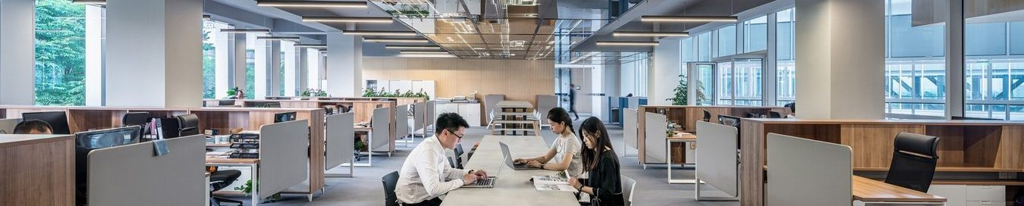

**Safely Back to Workplace  
GPS Health Defense Inc.**

*Bacteria & virus destroy solution provider…*

Wherever you are, whatever you are doing in the built environment, we can provide a health technology to clean the surfaces that you touch and the air you breath.

UV-C solutions is a proven technology when it comes to killing bacteria, viruses and other harmful microorganisms that pose a risk to human health.

Ultraviolet (UV-C) light kills or inactivates microorganisms by destroying nucleic acids and disrupting their RNA, DNA, Genome, leaving them unable to perform vital cellular functions or killing them, almost instantly because their cell structure cannot resist our products. For many years, UV germicidal products have been used for disinfection of air and surfaces within hospitals, care homes, laboratories and many other organizations where hygiene and cleanliness are of utmost importance. Our technologies have been quickly adapted from these super-sterile environments, as a proven weapon, now available for your armory to optimize protection for your family, friends, workforce and the public at large from harmful bacteria and pathogens in the air and on surfaces within any type of building.

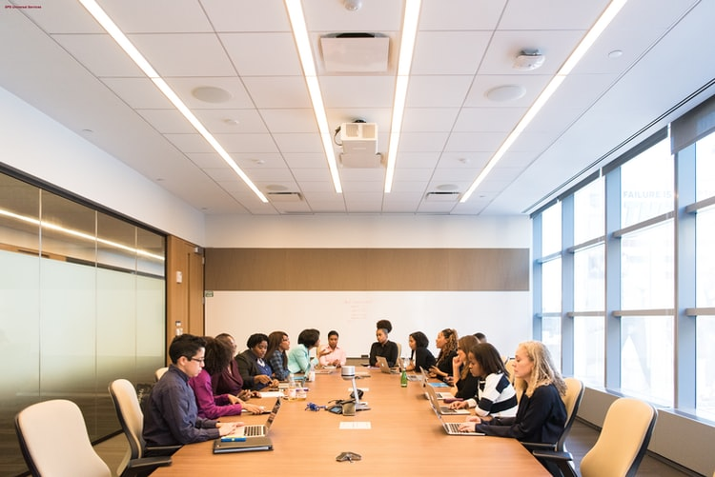

**Office Buildings Safely Bake to Office**

Office buildings are one of the most common places for someone to work and to develop any sort of illness, legionella aside, this nearly always down to the fact that there is close contact with other people which is further compounded by the poor air quality often found in offices environments.

Historically, this led to the rise of the phrase, “sick building syndrome (SBS)” where employees would develop illness due to the poor air quality. A major cause of SBS is microbes, being brought in from employees into the workplace and causing key systems in the HVAC system to harbor harmful microbes.

Today, the Covid-19 virus has taken SBS risk to a new level. Air quality and surface cleanliness are imperative to deal with this hazard properly.

Some are saying that a potential solution to this problem is to use more efficient HVAC filters which will reduce the number of microbes that can contaminate the system. That is true but it’s only half-way there in terms of effectiveness and on the downside, this system can cause a reduction in both the air flow and system pressure and the filters need very regular attention too. For offices, the most efficient method of sterilizing the air is installing a UV-C system because these simple inexpensive installations are able to kill over 99% of all pathogens in the target area.

The optimum solution for dealing with the spread of infectious diseases involves installing recirculating UV-C units. There are also Low-level systems which also help to disinfect air flows close to floor level which is where the highest risks lie as a result of the larger and potentially contaminated particles which fall from a sneeze or a cough. UVGI systems can also be used to ensure escalators, stairwells, kitchens and toilets can be thoroughly hygienically cleaned because these systems can be left on overnight on failsafe.



**Residential Housing, Caravans, B&B’s, Holiday homes**

For families, the home can be a source of illness due to the lack of effective air sterilization and air redistribution. When harmful microbes are brought into the home, they are able to settle on clothing and other fabrics such as carpets, pillows and curtains. When airborne these harmful microbes are able to stay in the air for up to 3 hours if there is no effective air redistribution and sterilization system in place.

Our technologies, when applied, will be able to de-activate or kill 99.99% of microbes from the air as it comes through the air distribution system. Our technology can also sterilize key components of the air distribution systems meaning that they do not harbor any harmful microbes where the pathogens thrive most.

Our surface sterilization systems will be able to kill pathogens on any surface within a matter of minutes, meaning that the property’s surfaces can be sterilized, when occupants are not in the room, reducing the risk of them contracting an illness.



**Apartments & Retirement Villages**

Many apartments have their own individual air distribution systems. Apartments have the highest concentration of microbes where more people come through hallways or communal areas, bringing potentially harmful microbes into the building and then the apartment.

If one wanted to be fully safe, an apartment would need to have its own air sterilization technology in place in order to stop the transmission of harmful microbes around the building.

The communal areas in apartment complexes need to be sterilized completely to reduce the risk of microbes being transmitted. Our surface sterilization technology will kill nearly all microbes on all surfaces including fungi in fabrics which can cause many respiratory problems when they release their spores.

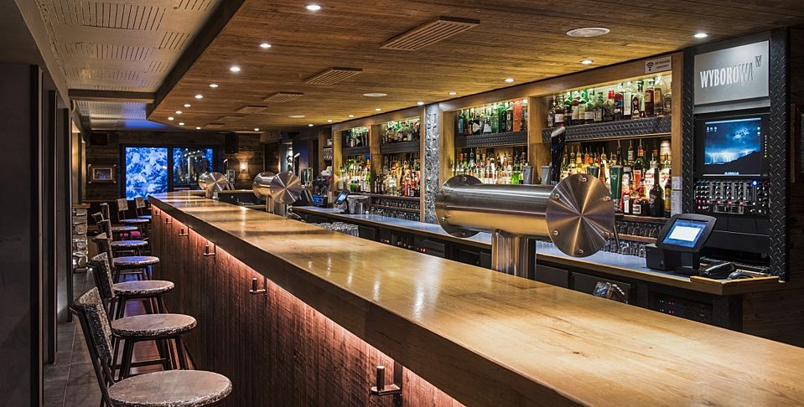

**Restaurants and Pubs**

Both restaurants and pubs face remarkably similar problems by the fact that nearly all the microbes that are brought inside by customers wanting to get something to drink or eat. This can cause a major risk because of people constantly coming in and out. This means that the risk of infection is high because each space might not be able to get sanitized in between new customers arriving and potentially breathing or touching microbes on surfaces.

Our proven UV-C technology, when installed in HVAC systems, is able to keep key components of the HVAC clean and microbe-free and deliver efficient air cleaning solutions. Such simple and inexpensive UV-C installations will greatly reduce the risk of transmission within the Restaurants and Pubs.

The other way that people could be exposed to dangerous microbes is from surface contamination. Fungi and microbes are prone to festering on surfaces especially fabric. Hard surfaces on floors and non-fabric furnishings are much safer and easier to clean too. Our surface decontamination technology will be able to sterilize all surfaces irrespective of whether fabric or not though, within a matter of minutes So, if there were a few minutes in between each sitting or a new group of customers coming in, that give the opportunity to make the surfaces sterile, allowing customers to feel safe, relaxed and at ease enjoying themselves rest-assured in the fact that the area has been sterilized and the air that they are breathing is safe.



**Hotels, Student Accommodation and Dormitories**

These sorts of accommodation have a high turn-over of people and daily visitors. They usually don’t always have individual air condition units in each room. This lack of airflow can allow microbes to stay airborne for up to three hours which can cause occupants in their room to contract an illness. Covid-19 is a potential risk to cleaning staff or the next visitor, if rooms are being turned around quickly.

The biggest human risks are presented by changing the bed linen because the upper portions and pillows are where the highest concentration of heavier human aerosol droplets (breathed, sneezed or coughed) will prevail, then around the sink and toilet pan areas. It is the heavier droplets (30microns+) which tend to carry the more dangerous bacteria and pathogens. If one is too rigorous in cleaning and lifting linen, then the microbes can be tossed and become airborne. This is a no! The cleaning methodology is crucial to reduce the risk to the cleaning staff and the next guests. We would also recommend that each pillow is swapped with a sterilized one prior to the next visitor and then, the one taken away is sterilized on both sides under UV-C for the appropriate period, wrapped and stored safely away for the next room change in the” Clean Laundry Room”. Our UV-C surface treatment technology can be applied in room on laundry and furnishings in the guests’ room and for object sterilization, in a dedicated room for such purposes.

Rooms in these sectors can all be retrofitted with our HVAC or retrofit air cleaning technology which not only helps to increase the airflow in the room but, also removes any microbes that are found within the air itself.

In an unoccupied room, our surface treatment technology will be able to kill any microbes that are within its range. Rooms, if unoccupied for longer periods, also tend to have high levels of tiny fungi growing on surfaces such as carpets chairs and bedsheets. Our technology will kill nearly all microbes in a matter of minutes. This coupled with our air sterilization technology will ensure that room air and the surfaces of objects there-in are clean and microbe-free.

Using our health-tech will allow you to inform your potential visitors that your hotel or residence is so incredibly safer than those who don’t deploy UV-C air or surface sterilization techniques so that they can enjoy their stay, safely and rest, assured.



**Educational Establishments**

Education facilities are historically, a focal point of disease transmission this is due to the repeated close encounters that they have with other students and teachers, this causes a rapid rate of spreading and infection as students will go home and give the disease to parents and they in turn will be able to spread the virus at their place of work. In the new order we live in, social distancing and management process’ are imperative to reduce these sorts of interaction risk.

One way to counteract the spreading of disease is with efficient air circulation systems which will be able to kill any airborne microbes while they air is recirculated through it. Upper Room UV-C Systems can also be put in place to significantly reduce localized spreading of the diseases in classes. These systems, located properly, will be able to massively reduce the overall spread and have been proven to reduce the amount of respiratory infections by a significant amount.

Museums and Libraries both contain vast quantities of books and materials where microbes can live and grow due to the minerals found in the paper and other materials.

Pre-Coved, over 234 species of microbes have been found on the books in libraries and museums. Any fabrics such as the carpet in a library have the ability to store microbes and they, especially promote the growth of fungi. This is a major issue for the area as foot traffic will release the microbes from the carpet and make them airborne.

Our proven UV-C technology, once in place, will be able to sterilize the air as it gets recirculated. Our system will also be able to keep key components of the cooling system, sterile and functioning at maximum efficiency. Keeping these key components free from microbes will also stop the further redistribution of the microbes.

Lower Room Systems would also be key for places such as entrances and hall ways where microbes from the outside are brought into the building are removed from circulation as soon as they come into the building.

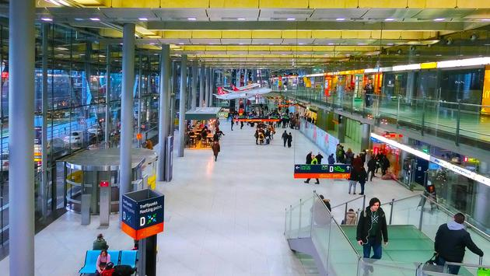

**Shopping Centers, Airports and Places of Assembly**

These places are characterized by large indoor spaces with large amounts of people who gather within them. In these buildings’ diseases are transmitted by direct and indirect surface contact, or by airborne microbes.

In facilities that recirculate air, our technology, when installed within the HVAC system and on key components within the HVAC systems, will ensure that airflow is kept at a maximum and the microbes are removed from circulation with maximum efficiency.

As these spaces usually have high ceilings, they would be ideal spaces for upper room systems to be installed to sterilize air, this would be particularly beneficial in facilities where natural ventilation is used as there is no other productive way for the air to be disinfected. High powered UV-C surface sterilization systems can also be used for areas that are not in use.



**Health Services and Care**

Hospitals can be amongst the most likely places that someone could contract an illness if there is an extremely high concentration of harmful microbes in the air and on the surfaces because of the concentration people with poor health being in the same building. There are many different types of applications for our UV-C technology that cover all the various aspects and usages of the spaces in healthcare facilities. Indeed, PP-L on the UK Government’s Coronavirus response suppliers list under Medical Services category.

There are general areas in hospitals and doctors’ surgeries where there are many people gathering or waiting for care. They can release microbes into the air via the human aerosol ie breathing, coughing and sneezing. Our air sterilization technology would keep the ventilation systems and the air itself, free of nearly all pathogens.

Lower and Upper room systems would also be very effective when it comes to sterilizing the floor and any other places that can harbor microbes but suitable clothing must be worn as the UV-C light can affect skin if not properly covered. Surface sterilization methods would only be able to be used when visitors and patients, in fact, all people, are absent or restricted from entering a space for a matter of minutes, depending on size, whilst the room is cleaned.

Another area in health care facilities that do benefit from our type of technology immensely is operating theatres as these the places in hospitals that need to be as sterile as possible as open wounds can become easily infected if there are any harmful microbes in the air, in the operating room it could be fatal. Our air sterilization system is extremely efficient at disinfecting the air while also keeping airflow at a maximum in order to disinfect the air more times per hour. We can also offer technology which will sterilize the surrounding hall-ways in order to make the environment as sterile as possible.

Our autonomous robotics products are also ideal for facilities where there are a significant number of rooms.

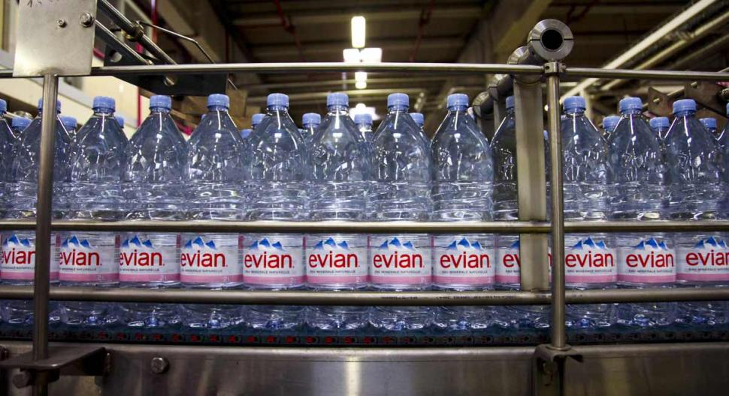

**Utilities**

UV-C can be used to sterilize in a variety of applications within the utility sector such as potable water delivered from your local water provider to your storage tanks and then your taps; waste water at local sewage plants; underground septic tanks on your property; underground springs or boreholes used for drinking; Chiller Plant and Heating Air-Conditioning & Ventilation (HVAC) Systems.

The UV-C technology can also be used in you use this water for internal or external use it can be treated prior to its use via our unique UV-C technology thus making it safe.

Each application is bespoke, and so will require a consultation prior to ascertain the requirements of your systems and what you are trying to achieve.

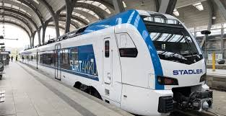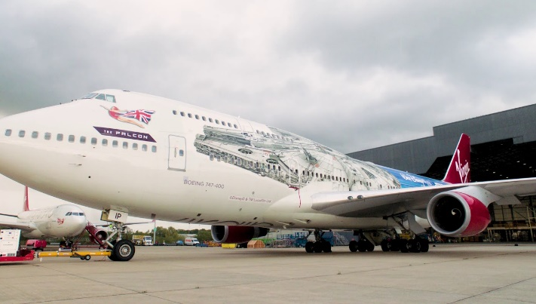

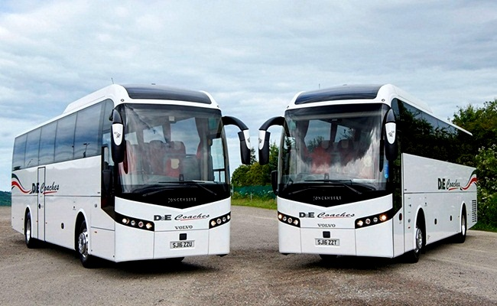

**Transport**

All modes of transport contain some sort of microbial hazard from people being crammed into confined spaces from trains, to boats, planes, buses, taxis and cars. Transport is therefore, a key place where transmission of microbes can take place and the risk of transmission is not only high due to concentrations of people in close proximity, it is the length of time that they are so close.

Aircraft, boats and trains are probably the most likely places for microbes and pathogens to be transmitted It is also one of the main ways that diseases are transported across borders. In a typical airplane, they use air filters which have a similar capability to MERV-13 filter. These HVAC filters on their own will reduce the number of microbes in the air but viruses but smaller microbes can still fit through the filters nevertheless. If these filters were to be coupled with our UV-C technology would allow people on the plane to breath cleaner air which helps to reduce the risk of transmission.

Trains and Buses especially crowded ones are also a potential focal point for the transmission of illness because there is little ventilation already in place, meaning microbes and fungal spores can remain in the air for up to 3 hours. Our technology when installed in the inefficient air redistribution system will massively increase the purity of the air which helps to significantly reduce the risk of transmission.

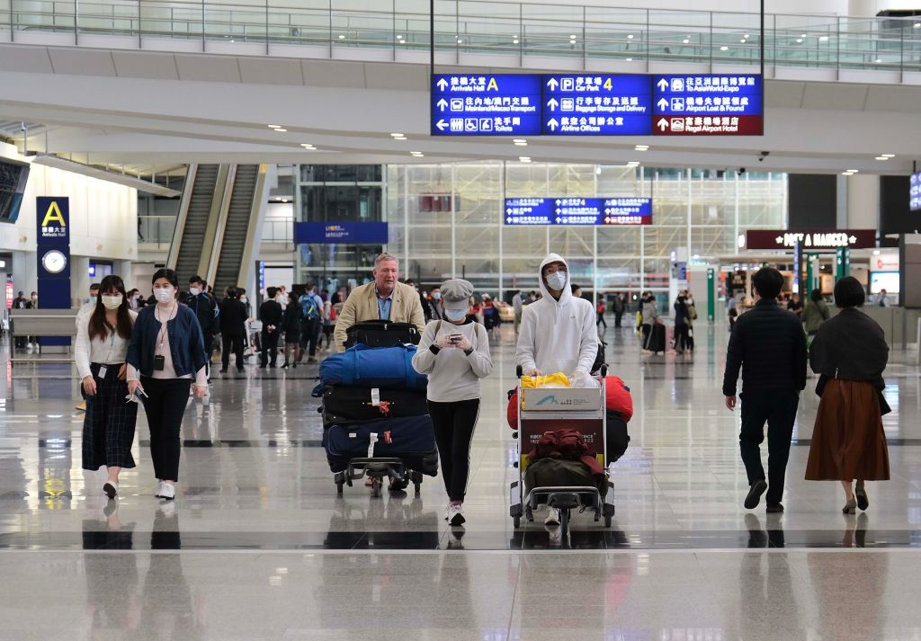**\\**

**Mobile goods, people & temporary situations**

Parcels, stethoscopes, face masks, mobile phones, tablets etc. can be effectively cleaned of viruses and germs in disinfection chambers. After 2 minutes 240 mg./cm² of UV-C will have been delivered, a value which kills everything of viral and bacterial origin, even in tissue or on rough surfaces. Sluices or entire rooms can be equipped with UV-C to disinfect incoming or outgoing goods. PP-L haves’ team who can travel to you and UV-C sterilize your mobile equipment at a time which is convenient to you and won’t disrupt your productivity.

waiting rooms or building entrance lobbies where many people stay or enter a facility in confined spaces, the concentration of viruses and bacteria in the air increases significantly. Worst of all, coughing and sneezing releases tiny droplets of viruses into the air. Our circulating air disinfection units draw in room air and effectively eradicate pathogens drawn into it with the UV-C fittings there-in.

One should not also forget places such as motorway services stations, public toilets, exhibitions, shift change-overs and construction sites where short-term high occupancy and higher airborne and surface contamination risks could prevail. Our technologies and installations can be perfectly adapted to enhance the protection of these environments too.

Finally, we also can provide mobile and autonomous units that can be moved room to room, sterilizing air and surfaces which are particularly effective once rooms are empty, people-fre

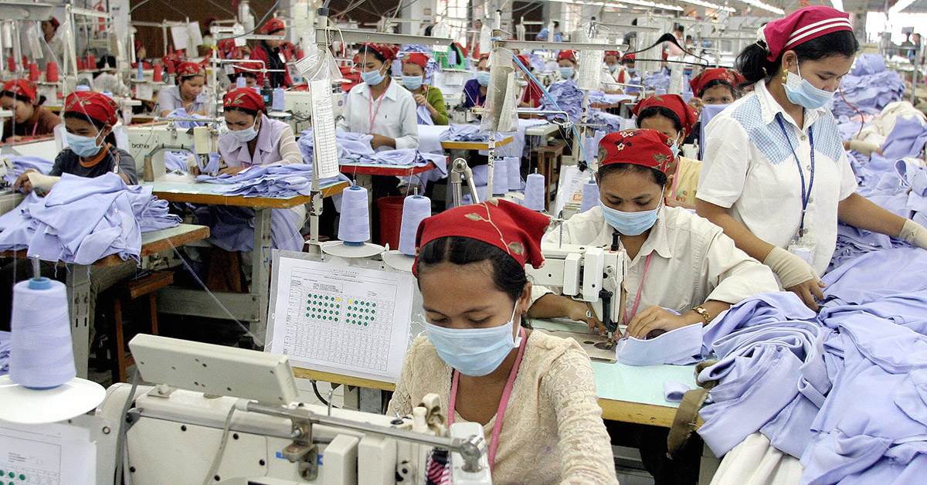

**Manufacturing**

There are two types of industrial facility: one which handles organic and one that handles inorganic goods and they both possess vastly different hazards.

Facilities that handle organic goods are much more prone to microbial hazards, whereas facilities that handle inorganic products are more likely to encounter pollutants which could lead to respiratory problems. UV-C systems have no real effect on non-microbial causes of these respiratory problems, however, if the problems are caused by and microbe or allergen or coronavirus, then the UV-C system will be able to remove them from the air.

Pre-corvid’s arrival anyway, dust particles in the air can contain chemicals and microbes which can cause the lungs to inflame this is because they have immunotoxin properties. Many more diseases are spread due to lack of poor air circulation, filtration and sterilization methods employed in the facility.

Some measures that could be put in place are improved air filtration systems which will help remove dust particles etc. from the air. There will have to be an increase in the air distribution as higher MERV value filters reduce the total efficiency and air distribution of the HVAC system. These are also expensive to maintain. However, the use of UVGI Systems within the HVAC system and on key components within the HVAC systems, will ensure that airflow is kept at a maximum and the microbes are destroyed, so there exists clean air in circulation. The use of more localized air recirculation systems may also pay dividends as bio-contamination will be removed swiftly without the contaminated air coming into contact with workers.



**Food Industries**

In the food industry there are four main types of health hazard that are involved with handling food these include, foodborne pathogen, spoilage microbes, microbial allergens and food allergens. Foodborne pathogens are mainly transmitted orally which can cause stomach and intestinal diseases, but they could also become airborne at any point during the products journey from storage to consumption.

Before Covid-19, foodborne and waterborne microbes caused the largest hazard to health in the food industry.

Our technology is able to target microbes and pathogens at every stage of the industrial process. During packaging and dispatch or goods returns for example, our systems will be able to remove any pathogens that are on the packaging or sterilize the surface of the products before they leave the factory. Another solution that is needed in the food industry is over head fluid tank irradiation, where microbes and other harmful organisms can be removed from the tank before they can spread.

Coronavirus, foodborne and waterborne microbes still pose the biggest threat to health of employees. The threat may not be there from the start, but some microbes are able to come airborne at any point this means that surface UV systems will help to remove most of the treat of microbes becoming airborne. If some microbes do manage to become airborne our air sterilization systems will be able to remove them from the air circulation system or if one does not exist, we can retrofit them.

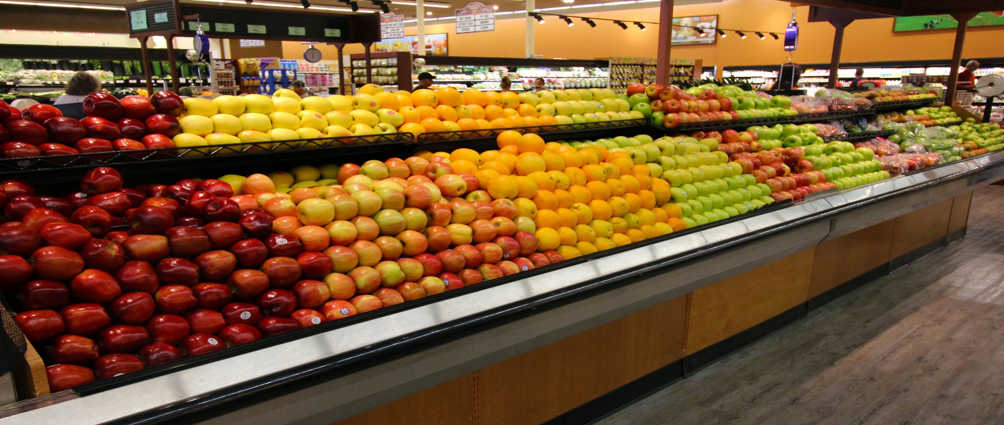

**Agriculture**

In agriculture, livestock sometimes is kept in confined spaces for short periods. The air in stalls gets a wholly new quality with UV-C chambers in times of PRRS viruses and FMD risks. Whether in material locks or disinfection stations, with UV-C systems, you’ll play it safe even in farming.

The technology that we deploy has been used in cold storage, food manufacturing, high-care processing, pharmaceutical manufacture, medical instruments and PPE for decades successfully.



**Sports Pitches & Courts**

UV-C light is calibrated to a very specific light spectrum to kill fungus and other diseases instantly. It could be deployed after matches to make sure that surface contamination risk is eradicated too from participants who might be pathogen carriers but as yet, exhibit no symptoms. For example, using such a 6 m wide UV-C device, takes merely 30-45min to cover 7,000 m2.

Foam markers at the sides of the UV-C unit show the groundman which area the tractor has already covered. The UV-C unit can be used on both natural and artificial grass surfaces. It can be fitted either at the front or at the rear of the tractor that is used for other maintenance work on the pitch.

For optimal results and also, environmentally, to reduce the need for pesticides considerably, it is advised to be used 2-3 times/week.